Literacy for Learning, Living, and Leading in Georgia 2019 (L4GA 2019) Cohort Two Application

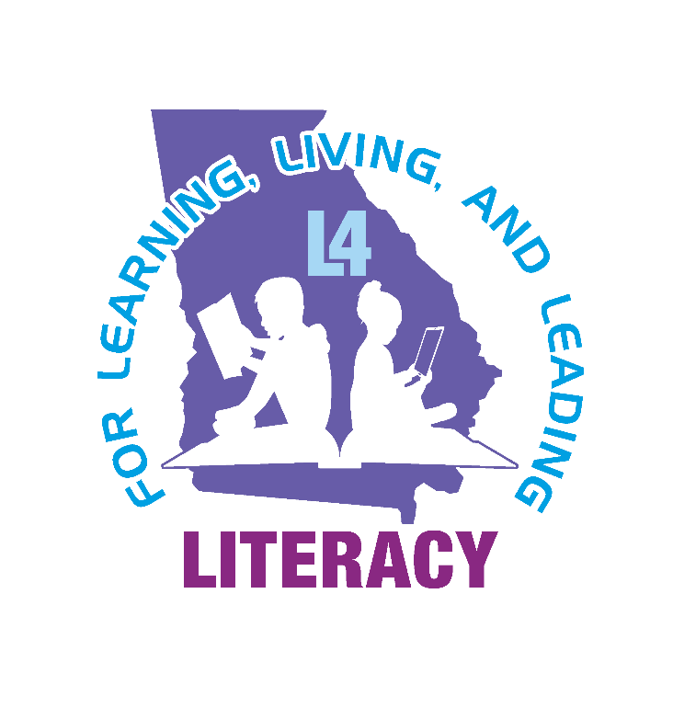

L4GA offers a unique approach to improving literacy by unifying community-driven action with research-proven instruction. Georgia’s state plan promises to improve literacy learning by establishing partnerships that utilize evidence-based practices (EBP) with proven success for improving student learning, teacher learning, classroom literacy instruction (birth to grade 12), school climate, family literacy and community-school partnerships.
Ideas
Please access the L4GA Grant Page for resources, potential partners, and technical assistance.
Sustainability
This funding focuses on creating sustainable systemic change. It is designed to support existing successes while encouraging systemic improvement in literacy for all students in a community. Sustainability is vital. Therefore, funded projects should support improvements to everyday practice for school leaders, community members, families, teacher educators, teachers, and students. When considering all aspects of the L4GA initiative, sustainability should be discussed. A solid plan should be in place to continue the work beyond the funding. Some examples for processes that create sustainability might include routine iterative use of data to inform leadership teams, the development of enduring community partnerships, and the strengthening of P-20 collaboration to ensure teacher quality across the career spectrum.
Word Limit Guidance
The L4GA scored sections have a suggested word count. Please adhere to the word count in each section. All sections except Section 9 (budget) will be scored.
Proposal Sections
Section 1: Local Education Agency (LEA)-Partnership Narrative (to be completed by LEA- Community Literacy Task Force)
15 points
This narrative is a highly important factor in ensuring that the reviewer understands the community, the local education agency (in most cases, this is a school district), the feeder system identified, and how this initiative will assist with the literacy development across the identified community, including in and out of schools. The LEA-Partnership Narrative should be limited to 2500 words.

Proposal’s Section | Content | Maximum Score
LEA-Partnership Narrative | Absolute Priorities for L4GA-Sub-grants:  - Identification of feeder system(s) and community served  - Identification of all LEA-Partnership partners, including early childhood service providers  - A brief description of the feeder system(s) identified, and history of the L4GA LEA-Partnership  - Population demographics of the community  - Climate Ratings for each school involved in the proposed partnership and/or status of implementation of PBIS Climate ratings received in 2019 are acceptable.  - Student literacy/ELA outcomes (milestones, lexiles, benchmark data) of the feeder system  Plan for engaging  - early childhood education providers  - P-20 research-practitioner partnership(s) and literacy faculty in the local teacher preparation programs  - community coalition | 15

Section 2: LEA-Partnership Management Plan and Key Personnel (to be completed by LEA- Community Literacy Task Force)
10 points
This section will apprise the reviewer of how the grant will be supported from the district level. Who are the key people involved in the grant? How will the grant function in terms of the whole district strategic plan? How will financial aspects of the grant be handled? Will there be a dedicated staff member at the district office with the responsibility of grants administration? Though this is certainly not an exhaustive list, these questions should be covered in your response. The LEA-Partnership Management Plan and Key Personnel should be limited to 1000 words.

Proposal’s Section | Content | Maximum Score
LEA-Partnership Management Plan and Key Personnel | LEA office support for grant management.  - Who are the key people involved in the grant?  - How will the grant ensure services in B-5?  - How will the grant function in terms of the whole district strategic plan and comprehensive needs assessment?  - How will financial aspects of the grant be handled?  - Will there be a dedicated staff member at the district office with the responsibility of grants administration?  Ability of the LEA to adequately administer the funding.  Any financial audit findings over the past three years should be discussed in this section.  Controls for spending should be pointed out. | 10

Section 3: Needs Assessment and Root Cause Analysis (to be completed by district office)
10 points
This section should describe the needs assessment process. What assets exist? How were root causes determined using the needs assessment process, and how will this information be used to develop a project that will impact all students birth to grade 12 in the LEA community? The Needs Assessment and Root Cause Analysis should be limited to 1000 words.

Proposal’s Section | Content | Maximum Score
Needs Assessment and Root Cause Analysis | B-5  Analysis of data related to other learning outcomes and school readiness.  Analysis of:  - Developmentally appropriate instruction and curriculum  - Professional learning provided to educators and directors  - Family engagement strategies  - Leadership effectiveness  - Other supports for the Whole Child and Well-rounded Education  - Coordination efforts with K-12  K-12  Comprehensive needs assessment and root cause analysis using Georgia’s System for Continuous Improvement (NOTE: LEAs should use the same approach as with their federal Comprehensive LEA Improvement Plans (CLIPs), District Improvement Plans (DIPs), and School Improvement Plans (SIPs); therefore, the L4GA plan should complement local strategic plans):  - Coherent Instructional System  - Past instructional initiatives  - Current instructional initiatives  - How to identify students for interventions  - Community and Family Engagement and Empowerment  - Engaged Leadership  - Positive Learning Environment  - Professional Capacity  - Other Supports for the Whole Child and Well-rounded Education  Coordination efforts with B-5, out-of-school providers, and community organizations.  For additional Technical Assistance for Community Partnerships, consider:  - GA Family Connection Partnership (GFCP; Get Georgia Reading Campaign)  - Governor’s Office of Student Achievement (GOSA)  - Literacy for All Georgia  - UGA Archway Partnership  - Georgia Partnership for Excellence in Education (GPEE) | 10

Section 4: Project Goals, Objectives, Activities, Outputs, Outcomes, and Supports Needed (to be completed by district office)
10 Points
This section should provide the reviewer with the actual implementation plan proposed for funding. The reviewer must understand who, what, when and how the actual performances will utilize assets and address the needs determined in the “root cause” analysis. It will not be enough to name programs and strategies; the application should show how the strategies and programs align to best practices and directly address the needs of the children in the community by working through community organizations, early care/learning providers, and schools. The plan should show how the community-level supports, instructional strategies, delivery models are consistent with Evidenced Based Practices and directly address the needs of the students, educators, parents, and community. The Project Goals, Objectives, Activities, Outputs, Outcomes, and Supports Needed should be limited to 1000 words.

Proposal’s Section | Content | Maximum Score
Project Goals, Objectives, Activities, Outputs, Outcomes, and Supports Needed | Implementation plan proposed for funding.  - The plan should show how the instructional strategies, delivery models and programs are consistent with EBP and directly address the needs of the students and educators.  - The plan should show how community partnerships are developed in ways consistent with evidence-based practices and directly address the needs of students and families.  For additional Technical Assistance for Community Partnerships consider:  - GA Family Connection Partnership (GFCP; Get Georgia Reading Campaign)  - Governor’s Office of Student Achievement (GOSA)  - Literacy 4 All  - UGA Archway Partnership  - Georgia Partnership for Excellence in Education (GPEE) | 10

Section 5: Assessment/Data Analysis Plan (to be completed by district office)
10 Points
In this section, indicate what community-level data will be utilized (e.g., poverty, transportation, healthcare, etc.) in addition to assessment data. For example, vision screeners may be an essential data point to target vision supports for students.
In addition, it is important to spell out specifically who, what, when and how the assessments will be given at the school level and how they will be analyzed by a team representing the early care providers, the community, local teacher educators/professional development providers, the schools, and the district.
The procedures involved in determining how instruction is developed based on the assessment data should be carefully described. Assessment protocols are specifically detailed including: who, what, and when the assessments will be given as well as analyzed. Procedures for educators’ analysis of local assessment data to inform instruction should also be included. The Assessment/Data Analysis Plan should be limited to 1000 words.

Proposal’s Section | Content | Maximum Score
Assessment & Data Analysis Plan | Assurance that assessment and evaluation requirements for the SEA will be completed  Estimated cost for assessments included in proposed LEA-Partnership budget  Detailed assessment protocols are specifically detailed including who, what, and when the assessments will be given as well as analyzed  Procedures for educators’ analysis of local assessment data to inform instruction | 10

Section 6: Professional Learning Strategies Identified on the Basis of Documented Need (to be completed by district office)
10 Points
Professional learning is a key component of the grant. There should be a direct tie to literacy instruction as well as include all teachers of reading/literacy including early care and learning providers, CTAE, Special Education teachers, all content teachers as well as community partners and parents as appropriate. This section of the grant should provide the district’s overall plan for engaging LEA-Partners with L4GA Professional Learning offerings. NOTE: LEA-Partners must agree to utilize their L4GA professional learning plan as their singular plan for literacy-related professional learning to avoid layering conflicting professional learning opportunities that could be available in a large LEA. The Professional Learning plan should be limited to 1000 words.

Proposal’s Section | Content | Maximum Score
Professional Learning Plan for B-5 and K-12 | Plan for engaging LEA-Partners with Professional Learning offerings:  - Time allocated for collaborative planning time per age/grade level team and vertical teams.  - Local PL supports (e.g., PLCs, collaborative planning, coaching, mentoring)  - Online PL supports  - Institutes  - Topics of interest for PL for each audience (e.g., early learning; literacy interventionists; community/family liaisons; school leaders, etc.) | 10

Section 7: Resources, Strategies, and Materials to Support Implementation of the Literacy Plan (to be completed by district office)
10 Points
This section details all of the strategies and human or instructional resources that will be used or paid for as a result of L4GA funding. They should all tie back to the needs assessment, student data, and root cause analysis. They should directly impact literacy, access to print, community engagement, student supports, instructional engagement and/or teacher support. It is not necessary to name specific products; generic descriptions are adequate. Technology purchases must be justified as a way to support literacy improvement. Personnel are allowable as a resource paid for by grant funds; however, please note that sustainability will be essential to the plan. The Resources, Strategies, and Materials section should be limited to 1000 words.

Proposal’s Section | Content | Maximum Score
Resources, personnel, strategies, and materials including technology to support implementation of the Literacy Plan | Instructional resources that will be used or purchased as a result of L4GA funding. Services that will be purchased as a result of the L4GA funding.  Notes:  - All expenditures should all tie back to community and student data, the comprehensive needs assessment, and root cause analysis.  - All expenditures should directly impact literacy, access to print, student engagement, and teacher support. They should be consistent with EBP.  - Expenditures should support activities primarily offered during the regular school day but may also include out-of-school time and instruction.  - This is not a technology grant; only technology supports vital to literacy improvement and instruction should be allocated.  - Any personnel expenditures are allowable but should be considered carefully as the grant funds are time-limited. Sustainability plans for maintaining positions after grants end should be considered.  Examples of strategies, human resources, or instructional resources:  - SEE-KS professional learning communities  - Growing Readers instructional coaching  - Tiered systems of support for students.  - Executive Coaching for literacy leadership | 10

Section 8: School/Center Literacy Plans (to be completed by each school and/or early care center involved)

15 Points

Each community served by an LEA is unique and therefore each school and early care center should have a detailed literacy plan that supports literacy implementation for children, families, educators, and community leaders who are part of the community. This literacy plan should be consistent with LEA-partnership goals, objectives, professional learning, and models of tiered supports. It also should support coordination of all resources available so that L4GA funding is used to fill strategic gaps determined in needs assessments. Each school/center literacy plan should be limited to 2500 words. It is not necessary to write the plan in narrative form if the school/LEA would rather develop or use a template.

Proposal’s Section | Content | Maximum Score
Literacy Plans for B-5 and K-12 | - Leadership Team members (including, but not limited to, teachers, specialized staff, school librarians, community organization representatives, teacher educators, families, and leaders)  - How the B-5 and K-12 literacy team will coordinate comprehensive literacy instruction, community activities, and literacy assessments to launch, monitor, and improve implementation  - How evidence-based practices and activities will be selected  - How to identify students for literacy intervention or other support services  - How to monitor the implementation and effectiveness of services | 15

Section 9: Budget Summary (to be completed by district office)
Unscored
Each application should have a budget summary in narrative form. The budget summary will highlight how the LEA/schools/centers/organizations plan to use their L4GA grant funds. The readers will have access to the budget summary so they can get a sense of the completed project. The budget summary will not be scored by readers. The budget summary will be reviewed by a committee of GaDOE staff including: Federal Program managers, Grants Accounting Personnel, L4GA program staff, and a member of the Audit team. The budget summary should be limited to 600 words.

Proposal’s Section | Content | Maximum Score
Budget | Notes:  Unallowable Expenditures  - Preparation of the Proposal: Costs to develop, prepare, and/or write the L4GA proposal cannot be charged to the grant directly or indirectly by either the agency or contractor.  - Pre-Award Costs: Pre-award costs may not be charged against the grant. Funds can be used only for activities conducted and costs incurred after the start date of the grant.  - Entertainment, Refreshments, Snacks not associated with a literacy event, community partnership event or parent event.  - Game systems and game cartridges are unallowable.  - Unapproved out of state or overnight field trips, including retreats, lock-ins, etc.  - Incentives (e.g., plaques, trophies, stickers, t-shirts, give-a-ways) not associated with literacy improvement. Books, periodical subscriptions, bookmarks etc. are allowable.  - Decorative Items not associated with literacy or family literacy.  - Purchase of Facilities  - Land acquisition  - Capital Improvements, Permanent Renovations except family literacy centers, media centers or reading centers in the classroom.  - Direct charges for items/services that the indirect cost rate covers  - Dues to organizations, federations, or societies for personal benefits. (Does not include professional organizations)  - Any costs not allowed for Federal projects per EDGAR, which may be accessed at http://www.ed.gov/policy/fund/reg/edgarReg/edgar.html  NOTE: This is NOT an all-inclusive list of unallowable expenses. If you have questions about unallowable expenses, please e-mail questions to: jmorrill@doe.k12.ga.us | No points

